Proposal for

PALU EVENT

July 2017

prepared for

Pan African Lawyers Union

Local Excursions

LE1: DURBAN CITY TOUR
Morning: 14h00 – 17h00
Duration: 3 Hours
Price Per Person: R 650

Depart at 14h00 from Durban and travel along Durban’s Golden Mile onto the entrance of Africa’s largest working Harbour. We then head onto the Yacht Mall along the Victoria Embankment before heading to Durban Botanical Gardens known to have one of the finest Orchid Houses in the world. Our last stop is a visit at Moses Mabhida Stadium, here you have the opportunity to take the SkyCar. It takes two minutes to reach the top of the arch. A 360’ view of Durban awaits you. See all of the city landmarks by day. Breathtaking!!!

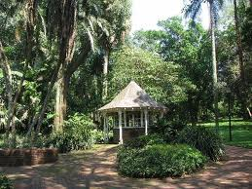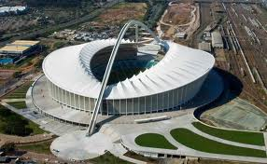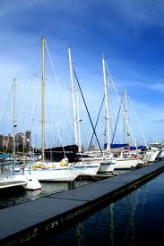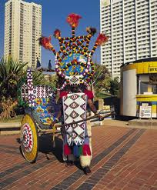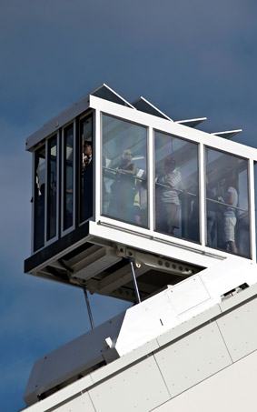

LE2: VALLEY OF 1000 HILLS
Morning: 09h00 – 13h00
Duration: 4 Hours
Price Per Person: R 755

Depart from Durban and travel via the suburbs of Westville, Pinetown, Kloof and Hillcrest to the Valley of 1000 Hills to “PHE-ZULU VILLAGE” for a Zulu Cultural Experience. Learn more about the traditions and beliefs of the Zulu custom. Join in with the Zulu Dancing and singing before walking through their Crocodile and Snake Park to learn more about Africa’s most feared reptile, the Crocodile!!!

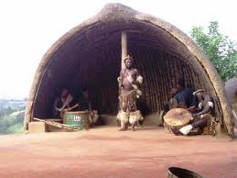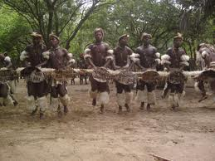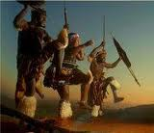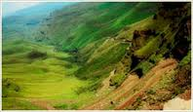

LE3: TALA PRIVATE GAME RESERVE
Morning: 09h00 – 13h00
Duration: 4 Hours
Price Per Person: r 1130

Travel West towards the Capital of Kwazulu – Natal Pietermaritzburg, to Tala Private Game Reserve. Enjoy a tow hour game drive through this wildlife conservancy hidden in the hills of a quite farming community. Tala’s mix of acacia thornveld open grasslands and sensitive wetland provides exceptional game viewing and bird watching, setting the stage for that perfect photograph. Tala is a wildlife sanctuary spanning over 3000 hectares providing good opportunities to see over 380 birds, rhino, kudu, hippo and giraffe.

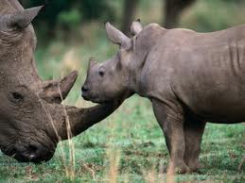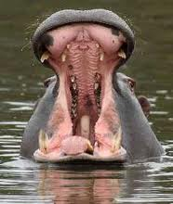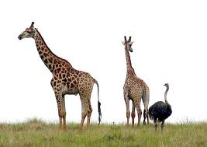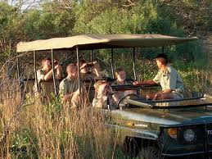

LE4: DURBAN CULTURAL
Morning: 09h00 – 13h00
Duration: 4 Hours
Price Per Person: R 720

INANDA, where there is more history per square centimentre than anywhere in South Africa! The valley of Inanda is rich in meaning – and right on Durban’s doorstep! In a cultural kaleidoscope very like our “rainbow nation” of today, Indian and African People have made a historic and lasting contribution to our heritage there, often against all odds. Through the bleak years of apartheid, the spirit of Inanda people ensures a continuity of this heritage and now the air is full of rebuilding and renewal. Tour Highlights: Inanda Route, Phoenix Settlement where one of the major leaders of the twentieth century, Mahatma Ghando originally worked out his philosophy of passive resistance against injustice. His followers, both in South Africa and later in the Indian Struggle for independence, successfully used his strategy to win freedom from oppression. Ghandi’s original home was destroyed in an anti-apartheid turbulence in of the 1980’s, but now has been re-built and re-dedicated as a monument to peace and justice, Ohlanga Institute – was the first African-run and African- funded educational institution in Southern Africa. The Institute was founded by the Rev Dr John Langalibalele Dube and first opened its doors in 1901. Dube was an educationalist, editor and also one of the founders of the ANC and its first president, Inanda Seminary School. Return to Durban at approximately 17h00.

LE5: uSHAKA MARINE WORLD
Morning: 09H00 – 13H00
Duration: 4 Hours
Price Per Person: R 450
Included: Seaworld Ticket & Transport

Transfer to the world class uShaka Marine World, situated on Durban South Beach. Our 11 dashing dolphins touch the hearts of guests every day with their unique personalities and irresistible charm. Featuring the larges aquarium in the southern hemisphere, with underground viewing galleries, extending 500 metres through a series of four superbly designed old ship wrecks, the uShaka aquarium is breath taking. Each and every display was designed to represent not only the natural habitat of the sea creatures, but to depict a story that ties in with the Phantom Ship Theme. Enjoy the Dolphin Show and Seal Presentation. Getting high at uShaka Marine World is not as dangerous and illegal as it sounds! Climb up to the top of the heart-stopping and adrenalin pumping Plunge freefall slide for the best view on site and plummet downward for gravity – defying wild ride. Try the Kamikaze ride for thrills of gut-wrenching pleasure, or race in sets of fearless five down the five-lane racer. And for the ultimate rush, brace yourself for the Drop Zone, Africa’s highest slide !! Return to your hotel at approximately 13h30

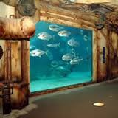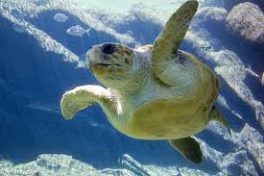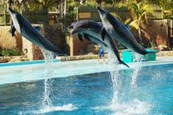

LE6: MIDLANDS MEANDER
Morning: 08h30 -16h30
Duration: 8 Hours
Price Per Person: R 1660
Included: Lunch

Take off to the Country, to the Midlands Meander, a treasure trove of Arts and Crafts shops and dozens of captivating ports of call. Enjoy a gentle day in the enchanting countryside of hills, woods and farmlands. Lunch stop. Return to Hotel at approximately 16h30.

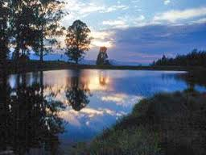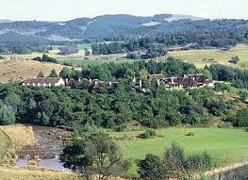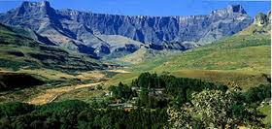

LE 7: SHAKALAND ZULU CULTURAL VILLAGE
Morning: 08h30 – 17h00
Duration: 8 ½ Hours
Price Per Person: R 1890
Included: Lunch

Depart from Durban and travel North to Zululand home of the great Zulu King “Shaka” and his wife Nandi, to Shakaland situated in the Nkawaleni Valley. An audiovisual presentation starts this awesome display of traditional Zulu Culture. Learn about the Beehive huts, the Sangoma and how the Zulu Warriors made their spears. Complete this wonderful experience with a traditional Zulu Style Lunch (alternative buffet also available). Return to Durban at approximately 17h00.

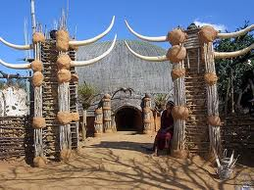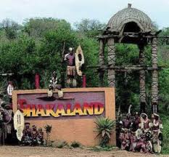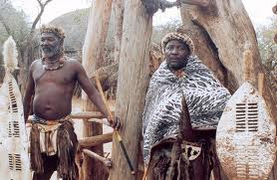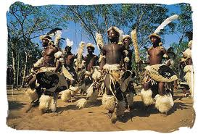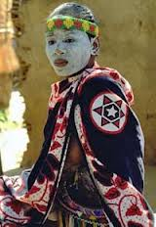

LE8: HLUHLUWE GAME RESERVE & ST LUCIA ESTUARY
Morning: 06h30 – 19h00
Duration: 12 ½ Hours
Price Per Person: TBA
Included: R 2765

Travel North through Zululand to Hluhluwe Game Reserve. Enjoy a game drive through Hluhluwe prior to departing for St Lucia Estuary (light lunch included) St Lucia is home to an astonishing diversity of ecosystems, birds, hippo and crocodile. The narrated boat cruise will take two hours after which we return to Durban.

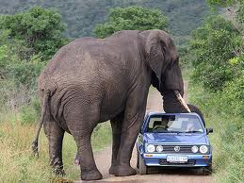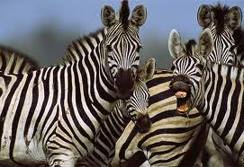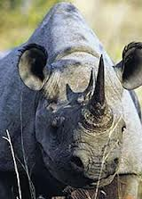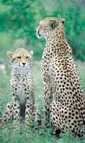

LE9: SANI PASS & LESOTHO EXPERIENCE
Morning: 06h30 – 18h30
Duration: 12 Hours
Price Per Person: R 2345
Included: Lunch

Depart from Durban and travel West through the Natal Midlands to the Southern Drakensberg Mountains via the Village Town of Himeville. On arrival transfer to closed 4x4 vehicle to begin your adventure up the highest pass in Africa, 3 967m above sea level. Cross the border into Lesotho, so passports are essential.

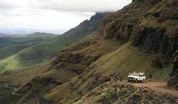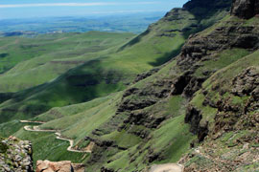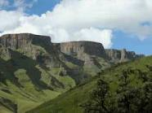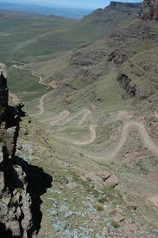

LE 10: ZULU VILLAGE & SAFARIS
Morning: 08h30 – 16h30
Duration: 8 Hours
Price Per Person: R 1635
Included: Lunch

We drive through the Natal Midlands to a Private Game Reserve for a morning Game Drive. Depart for the majestic Valley of 1000 Hills for lunch (Cash Bar) followed by a Zulu Cultural Experience at Phezulu.

Pre & Post Conference Tours

PR 1 & PT 1: HLUHLUWE GAME RESERVE & ST LUCIA ESTUARY – KWAZULU NATAL
Price Per Person: R 5180 Per Person Sharing
Single: R 5680 Single Rate
Duration: 2 Days / 1 Night
Includes: Accommodation, Transport, SATOUR Registered Guide and meals as stipulated.
Excludes: Anything of a Personal Nature and not mentioned above

PROGRAMME:
Day 1:
Depart at 07h00 from your Hotel and travel through the scenic sights of Zululand to one of Kwazulu Natal’s World Heritage Sites – St Lucia. Few places on earth and rival the bio-diversity of this 38 000 hectare Lake St Lucia Park. This vast unspoilt area has at its heart – Lake St Lucia, which is connected to the sea via a narrow estuary. Our first stop is at the launch site of our charter boat, for a two-hour boat cruise on this magical water wonderland. A narrated commentary will tell you about the different eco-systems found in this area and help you decipher what bird is calling as well as give you more fascinating information on the large water mammal the hippo as well as the devious Nile Crocodile that is lurking around. Lunch stop will be in the small fishing village of St Lucia (for clients own account. After lunch depart for Bushlands Game Lodge or similar for overnight stay and dinner.
Meals Included: - Dinner

Day 2:
Enjoy your full English breakfast at the lodge before departing to Hluhluwe Game Reserve, the oldest game reserve in Africa, in search for the Big Five!!! This game reserve is world famous for saving the black and white rhino from extinction. Explore the reserve where you may have the change of finding the elusive “Big Five”, as well as many other varieties and species of mammals and birds. Catch a glimpse of the old Africa where the mighty beasts once registered supreme.

Lunch today is included in the tour price. At 12h30 we will arrive at Hilltop Camp the main camp of the Hluhluwe Game Reserve, perched high on a hill overlooking the majestic hills and valleys of this pristine game reserve. Lunch today is included in the tour price. At 12h30 we will arrive at Hilltop Camp the main camp of the Hluhluwe Game Reserve, perched high on a hill overlooking the majestic hills and valleys of the pristine game reserve. Lunch will be served in their local restaurant. After lunch return to Durban.
Meals Included: Breakfast & Lunch

PR 2 & PT 2: DRAKENSBERG AND LESOTHO EXPERIENCE
Price Per Person: R 5180 per person sharing
Single: R 5680 Single Rate
Duration: 2 Days / 1 Night
Includes: Accommodation, Transport, SATOUR Registered Guide and meals as stipulated.
Excludes: Anything of a Personal Nature and not mentioned above

PROGRAMME:
Day 1:
Depart at 09h00 from Durban after breakfast for the scenic Valley of 1000 Hills for a Zulu Cultural Experience. On route to the Drakensberg we visit the Howick Falls. Overnight at a country lodge in Himevillle.
Meals Included: - Dinner

Day 2:
After breakfast begin your adventure in a 4x4 vehicle up the highest pass in South Africa to the “Roof of Africa” where we visit a Basotho Village before having lunch and then descend for our return journey to Durban. NB. PASSPORTS ARE REQUIRED (Passport holders requiring a visa into South Africa must have multiple entry visa}
Meals Included: Breakfast & Lunch

PR 3 & PT 3: BATTLEFIELDS ROUTE
Price Per Person: R 5180 per person sharing
Single: R 5680 Single Rate
Duration: 2 Days / 1 Night
Includes: Accommodation, Transport, SATOUR Registered Guide and meals as stipulated.
Excludes: Anything of a Personal Nature and not mentioned above

PROGRAMME:
Day 1:
Depart and travel North into Northern Zululand, where we will cover the awe inspiring battles of Rorke’s Drift and Isandlwana. Some fierce battles were fought here, and the first major encounter in the Anglo-Zulu war between the British Empire and the Zulu Kingdom was at Isandlwana. The battle of Rorke’s Drift, where the most Victoria Cross Medals for bravery were awarded to a single regiment, immediately followed by the British defeat at Isandlwana. Overnight at a guest lodge.
Meals Included: - Dinner

Day 2:
Depart after breakfast to visit the Talana Museum. Named after the hill at the base of which the museum is situated. Talana meaning “the shelf where precious items are stored” is a most appropriate name for this large and varied museum. We visit the battle site of Blood River and the Lady Smith Siege Museum before heading back to Durban.

Meals Included: Breakfast

PR 3 & PT 3: ST LUCIA, HLUHLUWE GAME RESERVE & SHAKALAND EXPERIENCE
Price Per Person: R 7900 per person sharing
Single: R 8880 Single Rate
Duration: 3 Days / 2 Nights
Includes: Accommodation, Transport, SATOUR Registered Guide and meals as stipulated.
Excludes: Anything of a Personal Nature and not mentioned above

PROGRAMME:
Day 1:
Depart 07h00 from your hotel and travel through the scenic sights of Zululand to one of Kwazulu – Natal’s World Heritage Sites – St Lucia. Few places on earth can rival the bio-diversity of this 38 000 hectares Lake St Lucia Park. This vast un-spoilt area has at its heart – Lake St Lucia, which is connected to the sea via a narrow estuary. Our first stop is at the launch site of our charter boat, for a two-hour boat cruise on this magical water wonderland and help you decipher what bird that is calling and give you more fascinating information on the large water mammal the hippo as well as the devious Nile Crocodile that is lurking around. Lunch stop will be in the small fishing village of St Lucia (for clients own account). Overnight at Bushlands Private Game Lodge or similar.
Meals Included: - Dinner

Day 2:
After breakfast depart for the Hluhluwe Game Reserve, the oldest game reserve in Africa, in search for the Big Five! This game reserve is world famous for saving the black and white rhino from extinction. Explore the reserve where you may have the chance of finding elusive “Big Five”, as well as many other varieties and species of mammals and birds. Catch a glimpse of the old Africa where the mighty beasts once reigned supreme. Lunch today is included in the tour price. At 12h30 we will arrive at Hilltop Camp the main camp of Hluhluwe Game Reserve, perched high on a hill overlooking the majestic hills and valleys of this pristine game reserve. Lunch in their local restaurant – why not try their famous Nyala Pie! Overnight at a lodge.
Meals Included: Breakfast, Lunch & Dinner

Day 3:
After breakfast it is time to bid this wildlife sanctuary farewell as we head back south towards Eshowe to Shakaland – home of the great Zulu King Shaka. Today we will enjoy the Nandi Experience ( Zulu Cultural Experience) – named after King Shaka’s wife – Nandi. An informative audio – visual presentation kicks off this wonderful experience. We are guided, by the local Shakaland Guide around a traditional Kraal. Riveting lectures and stories of typical Zulu customs and traditions are told in true imaginative Zulu style. Witnesses the Sangoma throwing the bones, or watch the pretty Zulu maidens go about their daily chorus. Of course a Zulu Cultural Experience would be incomplete with our a performance of true thundering Zulu dancing and singing from the Zulu warriors and maidens. We sit down to a traditional Zulu lunch, Zulu stew, and pap and samp and beans are just a few of the delicious items you will sample. After lunch we are wished Hamba Kahle by the Zulu Warrior – meaning go well, return to Durban arriving at approximately 16h30,
Meals Included: Breakfast & Lunch

Terms and Conditions

GENERAL CONDITIONS

- All Pre – Post Tours depart with a minimum of four (4) passengers unless otherwise stated. No tours will be confirmed until such time as four (4) passengers have booked and paid in full.

- Tours will be conducted in English only.

- Tours are sold subject to availability at time of booking. Bookings will be on first to book and pay in full basis.

- The Tour Operator reserves the right to alter or amend any tours, substitute accommodation or other arrangements, with appropriate alternatives without liability for compensation to the customer.

- Delegates planning to participate on any tour to the Mpumalanga, Kruger National Park and Zululand are advised to consult their General Practitioner with regards to a course of anti malaria medication. Delegates are also reminded to consult their General Practitioner on whether any other inoculations are required for the country or place they intend to visit.

- Delegates should be in possession of a valid passport for any of the tours conducted outside of South Africa. It is the responsibility of the delegates to ensure that his/her passport is valid for the country they intend visiting.

- Certain passport holders will require visas to enter certain of the countries. It is the responsibility of the delegate to ensure that he/she is in possession of the necessary visas for the tour he/she intends partaking in. VISAS SHOULD BE MULTIPLE ENTRY. The Tour Operator is not responsibility for arranging visas.

- Tours will be conducted in luxury air-conditioned 44 seater coaches, 18 seater Sprinters or mini buses dependent on the number of delegates partaking on each tour.

- Dress code for all tours is recommended as casual, cool clothing with comfortable walking shoes. Warm clothing for evenings is recommended. For those participating on any open vehicle safaris, a waterproof windbreaker is highly recommended.

- Please remember to bring, camera, film, suntan lotion, mosquito repellent and a sun hat.

- Please take note that on tours that make use of light aircraft as a means of transportation, luggage restrictions apply and are strictly adhered to.

- Airfares quoted are on a full fare economy basis.

- Prices include any domestic airfares mentioned in the itineraries.

- It is strongly advised that delegates take adequate insurance cover in the event of cancellation due to illness, accident and injury. Personal accident, medical assistance, personal liability and loss of baggage insurance is also recommended.

- Tailor made tours can be arranged on request. Please contact Shaka Tours & Safaris:

SHAKA TOURS & SAFIARS Contact Details:
E-mail address: karin@shakatours.com
Tel: +27 31 368 6588
Fax: +27 31 368 6589
Address: PO Box 473
Umhlanga Rocks
4320
South Africa

LOCAL EXCURSIONS

- Where possible excursions must be booked and paid for prior to the Conference by means of Credit card or bank transfer. Should payment be effected by bank transfer, kindly fax/email a copy of the bank transfer to Shaka Tours & Safaris.

It is important to indicate delegate’s surname on the bank transfer

- Availability will be strictly on a first come first served basis. Bookings for excursions can also be made on site’s tour desk.

- Once payment has been received in full for any excursion the following cancellation policy will apply:

Less than 24 hours notice prior to departure 50% cancellation fee
Less than 12 hours notice prior to departure 100% cancellation fee

- Local Tours include Entrance Fees
Transport
SATOUR Registered Tour Guide
Lunch on full day tours only
Light refreshments on half-day tours only

- Local Tours exclude Beverages at lunchtime on full day tours
Gratuities of any kind

- Method of Payment (refer to hotel accommodation, excursion and tours form)

Payment can be made either by credit card or bank transfer. Cheques and money orders will not be accepted.

Credit Card Payments

If paying by credit card provide the credit card details on the form and Shaka Tours & Safaris will automatically deduct full payment once they have confirmed your preferred excursion.

Bank Transfer Payments

It is important to indicate “Conference Name” as well as the delegates’ name on the bank transfer.

The transfer must be payable to Shaka Tours & Safaris.

Bank Details

Account Name: uShaka Tours & Safaris
Banking Institution: ABSA Bank Umhlanga Ridge
Account Numbers: 4072308096
Branch Code: 632005
SWIFT CODE: ABSAZAJJ

A copy of the transfer MUST be faxed / emailed to Shaka Tours & Safaris.

Please do not transfer payment to Shaka Tours & Safaris until you have been advised in writing that your preferred excursion is confirmed.

PRE –and POST Conference Tours

- Bookings for tours will close on 30 June 2017.

- Bookings received after 1 July 2017 will be subject to availability, and therefore will be categorized as a non-guaranteed booking.

- Full payment of the tour price is payable directly to Shaka Tours & Safaris. Payment should be made within seven days of receiving written confirmation from Shaka Tours & Safaris.

- No booking is secure until full payment is received. Shaka Tours & Safaris reserves the right to automatically release the booking unless full payment is received within the stated period.

- Shaka Tours & Safaris reserves the right to charge the following cancellation fees should a confirmed booking be cancelled within the following period :-

10% cancellation fee if cancelled less than 90 days prior to arrival
25% cancellation fee if cancelled less than 60 days prior to arrival
50% cancellation fee if cancelled less than 45 days prior to arrival
100% cancellation fee if cancelled less than 30 days prior to arrival

- Cancellations must be made in writing to Shaka Tours & Safaris and will be effective from date of receipt in our offices.

Shaka Tours & Safaris Contact Details :
E-mail address karin@shakatours.com
Tel: +27 31 368 6588
Fax: +27 31 368 6589
Address: PO Box 473
Umhlanga Rocks
4320
South Africa

- Tours include meals, accommodation and activities as indicated in the itinerary. Anything other than what has been indicated is strictly for the delegate’s own account. All extras should be pre-paid on departure. Shaka Tours & Safaris does not hold themselves liable for any extras account that the delegates incur.

- Method of Payment (refer to hotel accommodation, excursion and tours form)

Payment can be made either by credit card or bank transfer. Cheques and money orders will not be accepted.

Credit Card Payments

If paying by credit card provide the credit card details on the form and Shaka Tours & Safaris will automatically deduct full payment once they have confirmed your preferred excursion.

Bank Transfer Payments

It is important to indicate “PALU EVENT” as well as the delegates’ name on the bank transfer.

The transfer must be payable to Shaka Tours & Safaris.

Bank Details

Account Name: uShaka Tours & Safaris
Banking Institution: ABSA Bank Umhlanga Ridge
Account Numbers: 4072308096
Branch Code: 632005
SWIFT CODE: ABSAZAJJ

A copy of the transfer MUST be faxed / emailed to Shaka Tours & Safaris.

Please do not transfer payment to Shaka Tours & Safaris until you have been advised in writing that your preferred excursion is confirmed.

